

**JK Lakshmipat University**

[**Computer**](https://canvas.instructure.com/courses/8496533) **Organization and Architecture**

**ASSIGNMENT 3**

**Name – Indrajit Roy**

**Section – B**

**Roll No.- 2023BTECH037**

**Date of Submission – 15th November, 2024**

**Submitted To – DR. Pranab Roy Sir**

**D Flip Fop**

***● VHDL Code:***

***----------------------------------------------------------------------------------***

***-- Company:***

***-- Engineer:***

***--***

***-- Create Date: 17:21:24 10/15/2024***

***-- Design Name:***

***-- Module Name: d_ff - arch_diff***

***-- Project Name:***

***-- Target Devices:***

***-- Tool versions:***

***-- Description:***

***--***

***-- Dependencies:***

***--***

***-- Revision:***

***-- Revision 0.01 - File Created***

***-- Additional Comments:***

***--***

***----------------------------------------------------------------------------------***

***library IEEE;***

***use IEEE.STD_LOGIC_1164.ALL;***

***-- Uncomment the following library declaration if using***

***-- arithmetic functions with Signed or Unsigned values***

***--use IEEE.NUMERIC_STD.ALL;***

***-- Uncomment the following library declaration if instantiating***

***-- any Xilinx primitives in this code.***

***--library UNISIM;***

***--use UNISIM.VComponents.all;***

***entity d_ff is***

***port ( d : in std_logic;***

***clk : in std_logic;***

***enable : in std_logic;***

***reset : in std_logic;***

***q : out std_logic);***

***end d_ff;***

***architecture arch_dff of d_ff is***

***begin***

***process (clk,reset)***

***begin***

***if reset ='1' then***

***q <='0';***

***elsif rising_edge(clk) then***

***if enable ='1' then***

***q <= d;***

***end if;***

***end if;***

***end process;***

***end arch_dff;***

***● RTL Diagram:***

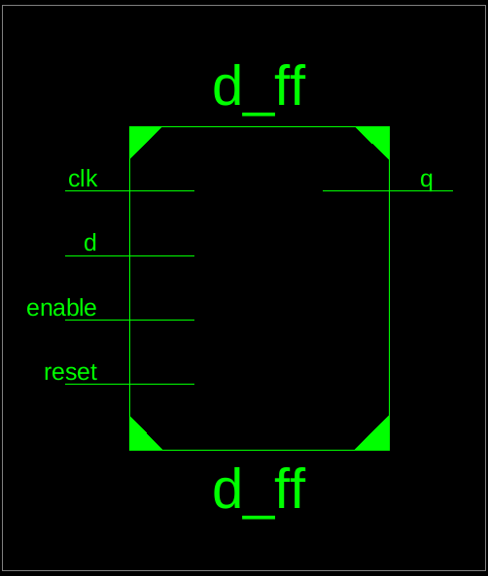 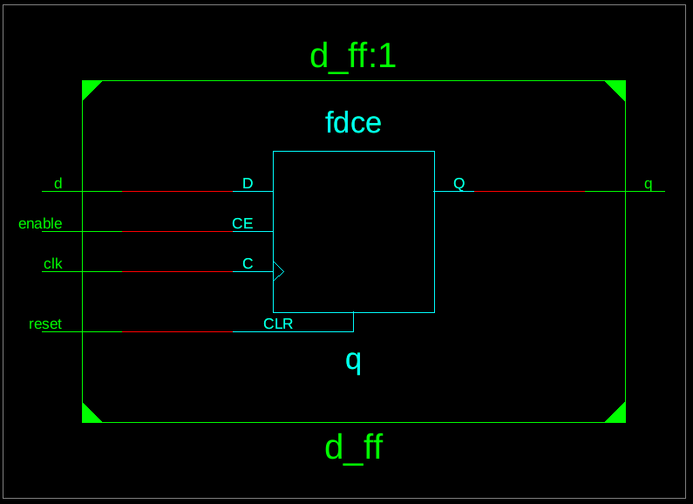

***● Testbench Code:***

***--------------------------------------------------------------------------------***

***-- Company:***

***-- Engineer:***

***-- Create Date: 17:40:34 10/15/2024***

***-- Design Name:***

***-- Module Name: /home/ise/Assignment3/d_ff_tb.vhd***

***-- Project Name: Assignment3***

***-- Target Device:***

***-- Tool versions:***

***-- Description:***

***-- VHDL Test Bench Created by ISE for module: d_ff***

***-- Dependencies:***

***-- Revision:***

***-- Revision 0.01 - File Created***

***-- Additional Comments:***

***-- Notes:***

***-- This testbench has been automatically generated using types std_logic and***

***-- std_logic_vector for the ports of the unit under test. Xilinx recommends***

***-- that these types always be used for the top-level I/O of a design in order***

***-- to guarantee that the testbench will bind correctly to the post-implementation***

***-- simulation model.***

***--------------------------------------------------------------------------------***

***LIBRARY ieee;***

***USE ieee.std_logic_1164.ALL;***

***-- Uncomment the following library declaration if using***

***-- arithmetic functions with Signed or Unsigned values***

***--USE ieee.numeric_std.ALL;***

***ENTITY d_ff_tb IS***

***END d_ff_tb;***

***ARCHITECTURE behavior OF d_ff_tb IS***

***-- Component Declaration for the Unit Under Test (UUT)***

***COMPONENT d_ff***

***PORT(***

***d : IN std_logic;***

***clk : IN std_logic;***

***enable : IN std_logic;***

***reset : IN std_logic;***

***q : OUT std_logic***

***);***

***END COMPONENT;***

***--Inputs***

***signal d : std_logic := '0';***

***signal clk : std_logic := '0';***

***signal enable : std_logic := '0';***

***signal reset : std_logic := '0';***

***--Outputs***

***signal q : std_logic;***

***BEGIN***

***-- Instantiate the Unit Under Test (UUT)***

***uut: d_ff PORT MAP (***

***d => d,***

***clk => clk,***

***enable => enable,***

***reset => reset,***

***q => q***

***);***

***-- Clock process definitions***

***clk_process :process***

***begin***

***clk <= '0';***

***wait for 5 ns;***

***clk <= '1';***

***wait for 5 ns;***

***end process;***

***-- Stimulus process***

***stim_proc: process***

***begin***

***d <= '0';***

***enable <= '0';***

***reset <= '0';***

***wait for 20 ns;***

***reset <= '1';***

***wait for 10 ns;***

***reset <= '0';***

***wait for 10 ns;***

***d <= '1';***

***enable <= '1';***

***wait for 20 ns;***

***d <= '0';***

***enable <= '0';***

***wait for 20 ns;***

***reset <= '1';***

***wait for 10 ns;***

***reset <= '0';***

***wait for 10 ns;***

***enable <= '1';***

***d <= '1';***

***wait for 20 ns;***

***enable <= '0';***

***d <= '0';***

***wait for 20 ns;***

***wait;***

***end process;***

***END;***

***● Waveform:***

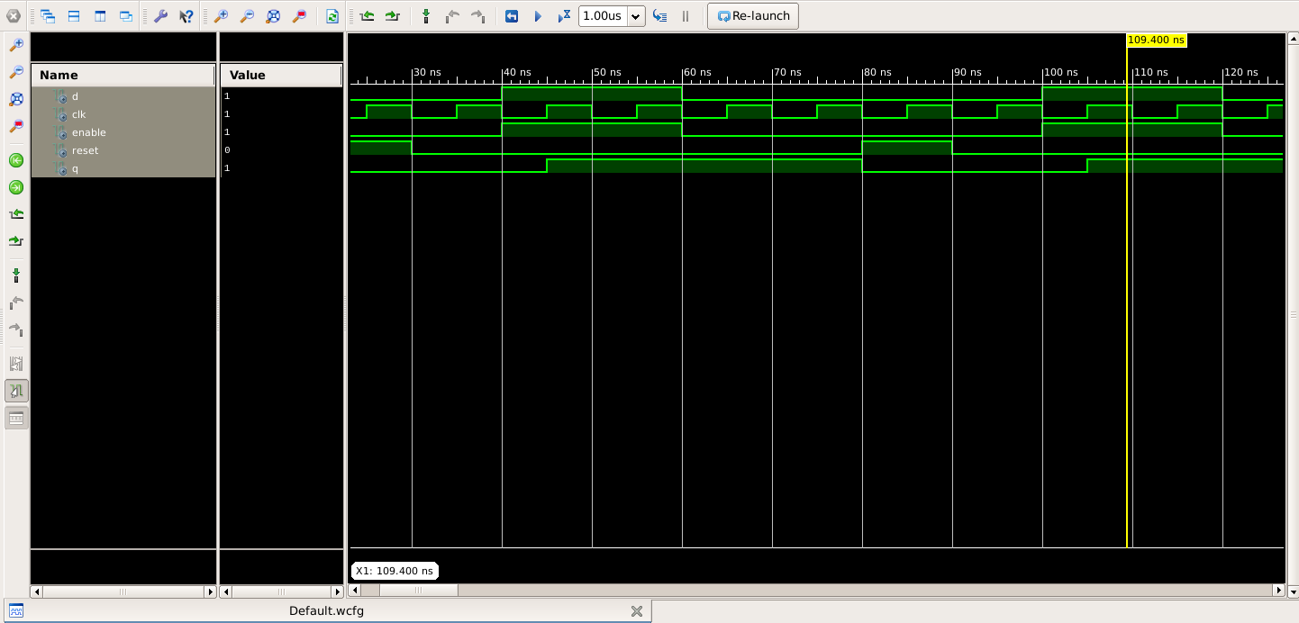

**Question 1**

**Develop a VHDL model to design a four bit Parallel in parallel out register using D flip flop components. Use an enable and reset input pin to enable and reset the registers.**

**Aim :** **To design and implement a 4-bit Parallel-In Parallel-Out (PIPO) register using D flip-flop components in VHDL, with functionality to enable data loading and reset the register to its initial state.**

**Block Diagram :**

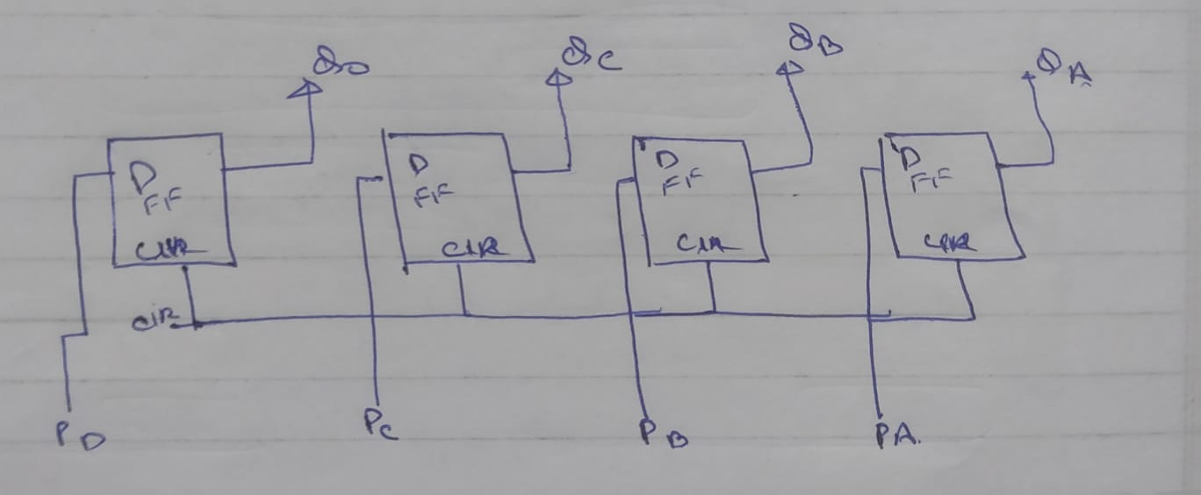***● VHDL Code:***

***----------------------------------------------------------------------------------***

***----------------------------------------------------------------------------------***

***-- Company:***

***-- Engineer:***

***--***

***-- Create Date: 17:18:25 10/15/2024***

***-- Design Name:***

***-- Module Name: pipo - Behavioral***

***-- Project Name:***

***-- Target Devices:***

***-- Tool versions:***

***-- Description:***

***--***

***-- Dependencies:***

***--***

***-- Revision:***

***-- Revision 0.01 - File Created***

***-- Additional Comments:***

***--***

***----------------------------------------------------------------------------------***

***library IEEE;***

***use IEEE.STD_LOGIC_1164.ALL;***

***-- Uncomment the following library declaration if using***

***-- arithmetic functions with Signed or Unsigned values***

***--use IEEE.NUMERIC_STD.ALL;***

***-- Uncomment the following library declaration if instantiating***

***-- any Xilinx primitives in this code.***

***--library UNISIM;***

***--use UNISIM.VComponents.all;***

***entity pipo is***

***port(***

***clk:in std_logic;***

***enable:in std_logic;***

***reset:in std_logic;***

***data_in:in std_logic_vector(3 downto 0);***

***data_out:out std_logic_vector (3 downto 0)***

***);***

***end pipo;***

***architecture Behavioral of pipo is***

***component d_ff***

***port ( d : in std_logic;***

***clk : in std_logic;***

***enable : in std_logic;***

***reset : in std_logic;***

***q : out std_logic);***

***end component;***

***begin***

***step1: d_ff Port map (d=> data_in(0),clk=> clk,enable => enable,reset => reset,q=>data_out(0));***

***step2: d_ff Port map (d=> data_in(1),clk=> clk,enable => enable,reset => reset,q=>data_out(1));***

***step3: d_ff Port map (d=> data_in(2),clk=> clk,enable => enable,reset => reset,q=>data_out(2));***

***step4: d_ff Port map (d=> data_in(3),clk=> clk,enable => enable,reset => reset,q=>data_out(3));***

***end Behavioral;***

***● RTL Diagram:***

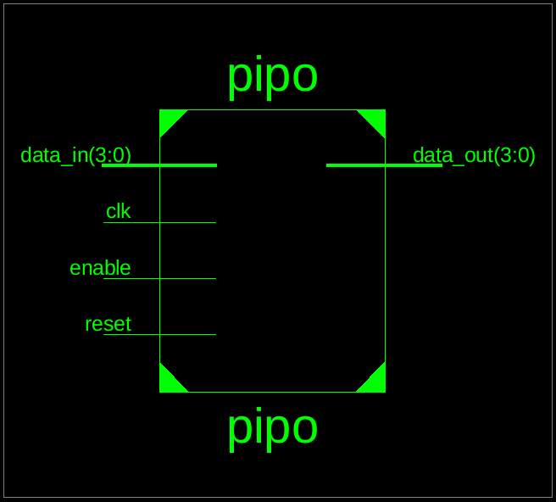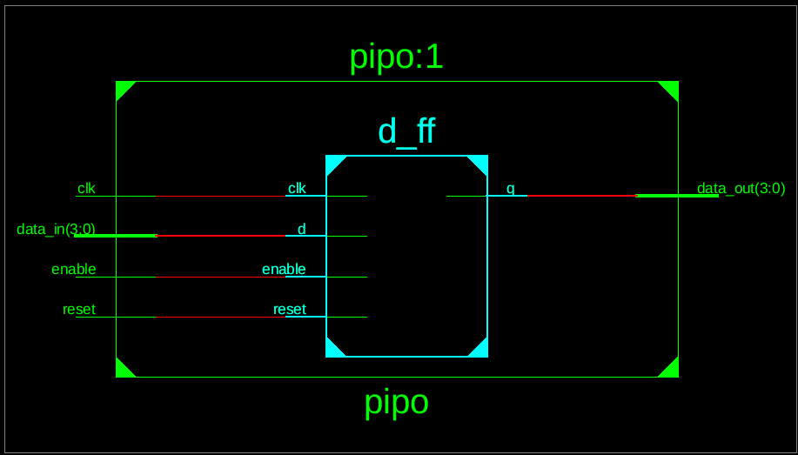

***● Testbench Code:***

***--------------------------------------------------------------------------------***

***-- Company:***

***-- Engineer:***

***-- Create Date: 17:31:19 10/15/2024***

***-- Design Name:***

***-- Module Name: /home/ise/Assignment3/pipo_tb.vhd***

***-- Project Name: Assignment3***

***-- Target Device:***

***-- Tool versions:***

***-- Description:***

***--***

***-- VHDL Test Bench Created by ISE for module: pipo***

***--***

***-- Dependencies:***

***--***

***-- Revision:***

***-- Revision 0.01 - File Created***

***-- Additional Comments:***

***--***

***-- Notes:***

***-- This testbench has been automatically generated using types std_logic and***

***-- std_logic_vector for the ports of the unit under test. Xilinx recommends***

***-- that these types always be used for the top-level I/O of a design in order***

***-- to guarantee that the testbench will bind correctly to the post-implementation***

***-- simulation model.***

***--------------------------------------------------------------------------------***

***LIBRARY ieee;***

***USE ieee.std_logic_1164.ALL;***

***-- Uncomment the following library declaration if using***

***-- arithmetic functions with Signed or Unsigned values***

***--USE ieee.numeric_std.ALL;***

***ENTITY pipo_tb IS***

***END pipo_tb;***

***ARCHITECTURE behavior OF pipo_tb IS***

***-- Component Declaration for the Unit Under Test (UUT)***

***COMPONENT pipo***

***PORT(***

***clk : IN std_logic;***

***enable : IN std_logic;***

***reset : IN std_logic;***

***data_in : IN std_logic_vector(3 downto 0);***

***data_out : OUT std_logic_vector(3 downto 0)***

***);***

***END COMPONENT;***

***--Inputs***

***signal clk : std_logic := '0';***

***signal enable : std_logic := '0';***

***signal reset : std_logic := '0';***

***signal data_in : std_logic_vector(3 downto 0) := (others => '0');***

***--Outputs***

***signal data_out : std_logic_vector(3 downto 0);***

***BEGIN***

***-- Instantiate the Unit Under Test (UUT)***

***uut: pipo PORT MAP (***

***clk => clk,***

***enable => enable,***

***reset => reset,***

***data_in => data_in,***

***data_out => data_out***

***);***

***-- Clock process definitions***

***clk_process :process***

***begin***

***while true loop***

***clk <= '0';***

***wait for 1 ns;***

***clk <= '1';***

***wait for 1 ns;***

***end loop;***

***end process;***

***-- Stimulus process***

***stim_proc: process***

***begin***

***reset <= '1';***

***wait for 200 ns;***

***reset <= '0';***

***wait for 200 ns;***

***enable <= '1';***

***data_in <= "1010";***

***wait for 200 ns;***

***data_in <= "1100";***

***wait for 200 ns;***

***enable <= '0';***

***wait for 200 ns;***

***reset <= '1';***

***wait for 200 ns;***

***reset <= '0';***

***wait for 200 ns;***

***enable <= '1';***

***data_in <= "0110";***

***wait for 200 ns;***

***wait;***

***end process;***

***END;***

***● Waveform:***

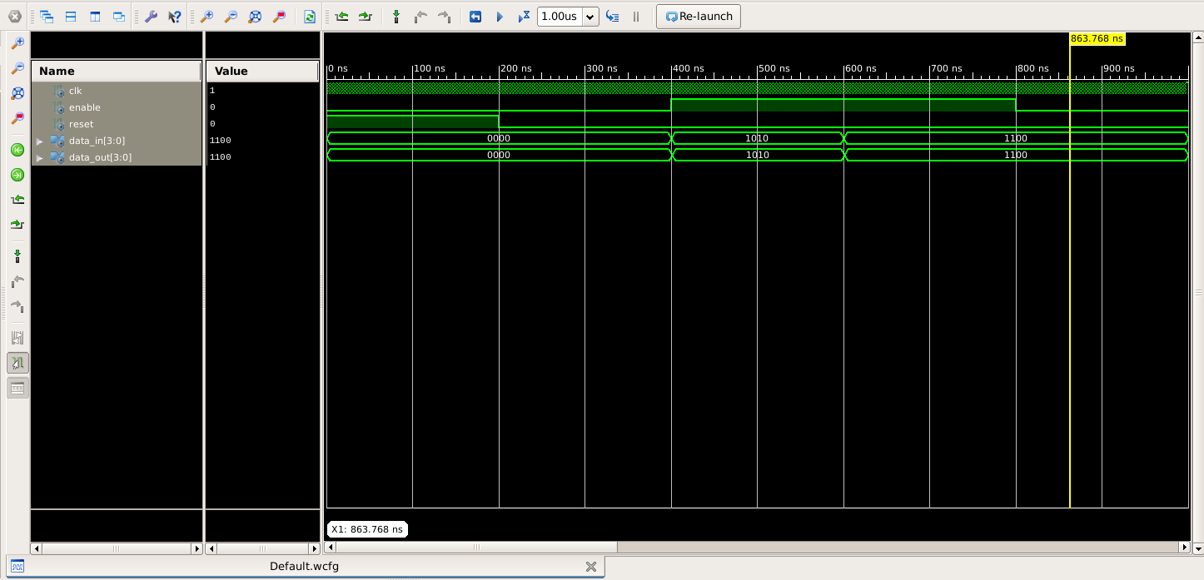

**Question 2**

**Develop a VHDL model to design a four bit Serial in Serial out register using D flip flop components. Use an enable and reset input pin to enable and reset the registers.**

**Aim : To develop a VHDL model for designing a 4-bit Serial-In Serial-Out (SISO) shift register using D flip-flop components. The design will include an enable input to control data shifting and a reset input to clear the register contents**

**Circuit Diagram :**

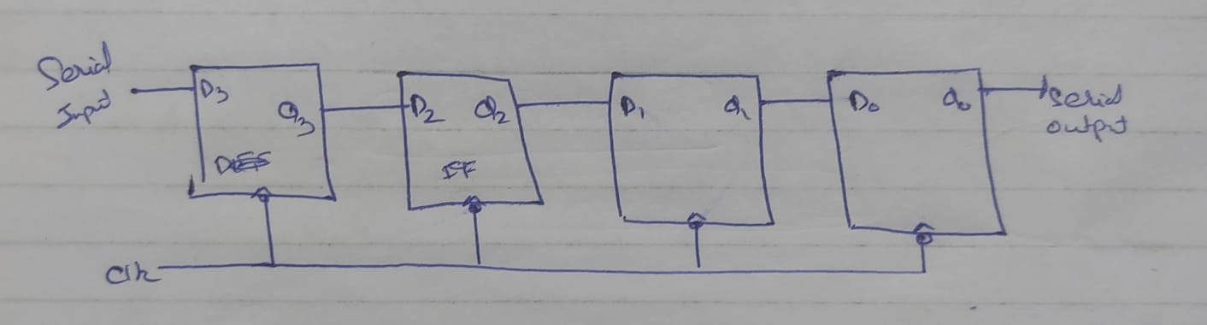

***● VHDL Code:***

***----------------------------------------------------------------------------------***

***-- Company:***

***-- Engineer:***

***--***

***-- Create Date: 18:07:21 10/15/2024***

***-- Design Name:***

***-- Module Name: siso - Behavioral***

***-- Project Name:***

***-- Target Devices:***

***-- Tool versions:***

***-- Description:***

***--***

***-- Dependencies:***

***--***

***-- Revision:***

***-- Revision 0.01 - File Created***

***-- Additional Comments:***

***--***

***----------------------------------------------------------------------------------***

***library IEEE;***

***use IEEE.STD_LOGIC_1164.ALL;***

***-- Uncomment the following library declaration if using***

***-- arithmetic functions with Signed or Unsigned values***

***--use IEEE.NUMERIC_STD.ALL;***

***-- Uncomment the following library declaration if instantiating***

***-- any Xilinx primitives in this code.***

***--library UNISIM;***

***--use UNISIM.VComponents.all;***

***entity siso is***

***port(***

***clk:in std_logic;***

***enable:in std_logic;***

***reset:in std_logic;***

***serial_in:in std_logic;***

***serial_out:out std_logic***

***);***

***end siso;***

***architecture Behavioral of siso is***

***component d_ff is***

***port ( d : in std_logic;***

***clk : in std_logic;***

***enable : in std_logic;***

***reset : in std_logic;***

***q : out std_logic);***

***end component;***

***signal q0,q1,q2,q3:std_logic;***

***begin***

***step1:d_ff port map(d=>serial_in,clk=>clk,enable=>enable,reset=>reset,q=>q3);***

***step2:d_ff port map(d=>q3,clk=>clk,enable=>enable,reset=>reset,q=>q2);***

***step3:d_ff port map(d=>q2,clk=>clk,enable=>enable,reset=>reset,q=>q1);***

***step4:d_ff port map(d=>q1,clk=>clk,enable=>enable,reset=>reset,q=>q0);***

***serial_out<=q0;***

***end Behavioral;***

***● RTL Diagram:***

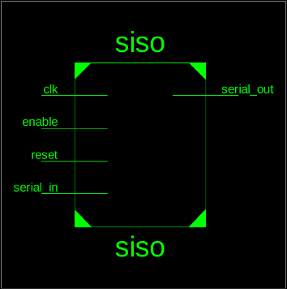 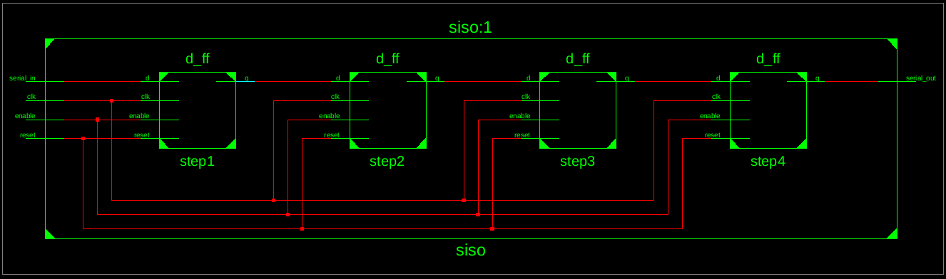

***● Testbench Code:***

***--------------------------------------------------------------------------------***

***-- Company:***

***-- Engineer:***

***--***

***-- Create Date: 18:19:38 10/15/2024***

***-- Design Name:***

***-- Module Name: /home/ise/Assignment3/siso_tb.vhd***

***-- Project Name: Assignment3***

***-- Target Device:***

***-- Tool versions:***

***-- Description:***

***--***

***-- VHDL Test Bench Created by ISE for module: siso***

***--***

***-- Dependencies:***

***--***

***-- Revision:***

***-- Revision 0.01 - File Created***

***-- Additional Comments:***

***--***

***-- Notes:***

***-- This testbench has been automatically generated using types std_logic and***

***-- std_logic_vector for the ports of the unit under test. Xilinx recommends***

***-- that these types always be used for the top-level I/O of a design in order***

***-- to guarantee that the testbench will bind correctly to the post-implementation***

***-- simulation model.***

***--------------------------------------------------------------------------------***

***LIBRARY ieee;***

***USE ieee.std_logic_1164.ALL;***

***-- Uncomment the following library declaration if using***

***-- arithmetic functions with Signed or Unsigned values***

***--USE ieee.numeric_std.ALL;***

***ENTITY siso_tb IS***

***END siso_tb;***

***ARCHITECTURE behavior OF siso_tb IS***

***-- Component Declaration for the Unit Under Test (UUT)***

***COMPONENT siso***

***PORT(***

***clk : IN std_logic;***

***enable : IN std_logic;***

***reset : IN std_logic;***

***serial_in : IN std_logic;***

***serial_out : OUT std_logic***

***);***

***END COMPONENT;***

***--Inputs***

***signal clk : std_logic := '0';***

***signal enable : std_logic := '0';***

***signal reset : std_logic := '0';***

***signal serial_in : std_logic := '0';***

***--Outputs***

***signal serial_out : std_logic;***

***BEGIN***

***-- Instantiate the Unit Under Test (UUT)***

***uut: siso PORT MAP (***

***clk => clk,***

***enable => enable,***

***reset => reset,***

***serial_in => serial_in,***

***serial_out => serial_out***

***);***

***-- Clock process definitions***

***clk_process :process***

***begin***

***clk <= '0';***

***wait for 50 ns;***

***clk <= '1';***

***wait for 50 ns;***

***end process;***

***-- Stimulus process***

***stim_proc: process***

***begin***

***reset <= '1';***

***wait for 10 ns;***

***reset <= '0';***

***enable <= '1';***

***serial_in <= '1'; wait for 10 ns;***

***serial_in <= '0'; wait for 10 ns;***

***serial_in <= '0'; wait for 10 ns;***

***serial_in <= '1'; wait for 10 ns;***

***enable <= '0';***

***wait for 200 ns;***

***reset <= '1';***

***wait for 100 ns;***

***reset <= '0';***

***wait;***

***end process;***

***END;***

***● Waveform:***

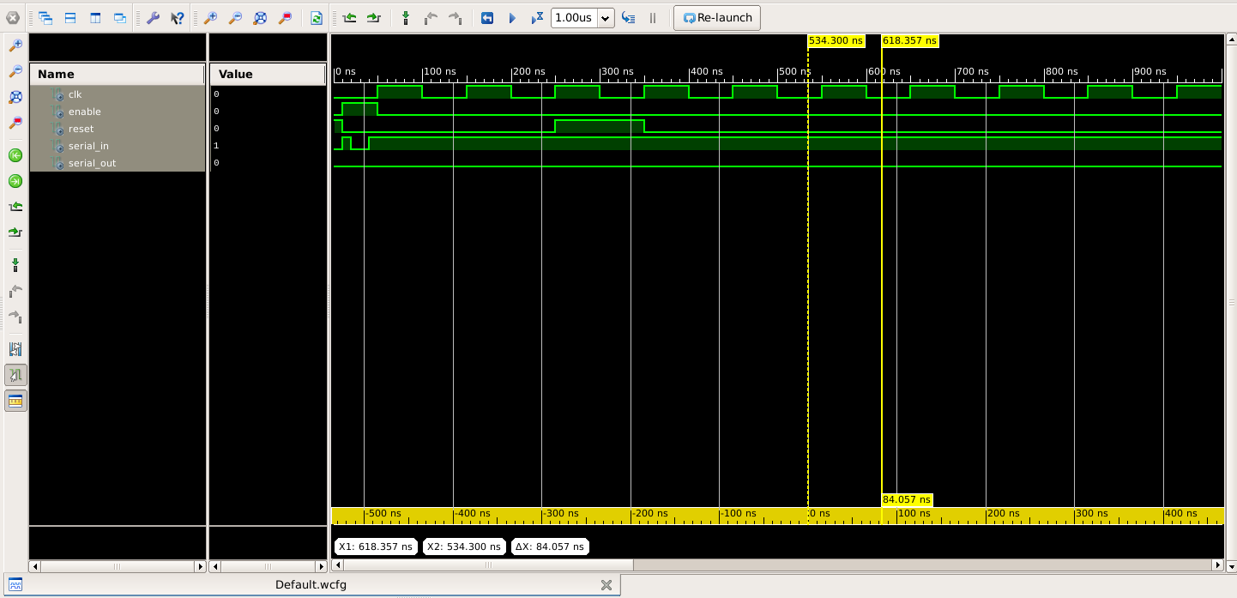

**Question 3**

**Develop a VHDL model to design a four bit Parallel/Serial in Serial out register using D flip flop components. Use an enable and reset input pin to enable and reset the registers. Use a mode input pin to decide whether the input mode is serial or parallel.**

**Aim : To develop a VHDL model for designing a 4-bit Parallel/Serial-In Serial-Out (PISO) shift register using D flip-flop components. The design will include an enable input to control data shifting, a reset input to clear the register contents, and a mode input to select between parallel or serial data input.**

**Block Diagram :**

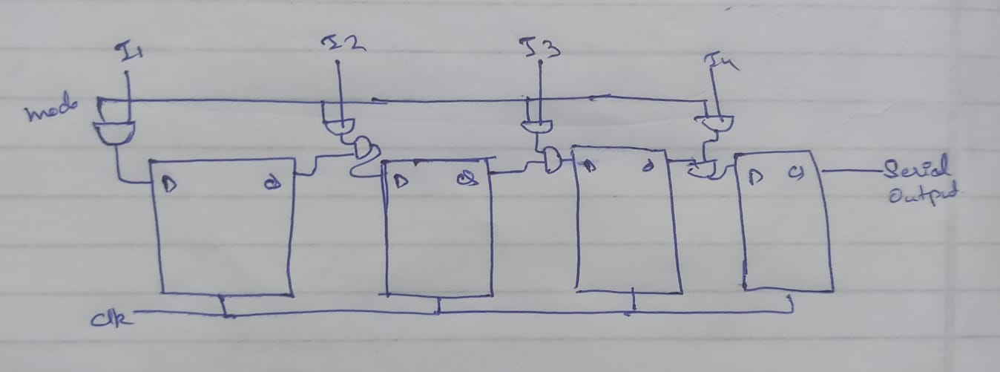

***● VHDL Code:***

***----------------------------------------------------------------------------------***

***----------------------------------------------------------------------------------***

***-- Company:***

***-- Engineer:***

***--***

***-- Create Date: 18:25:52 10/15/2024***

***-- Design Name:***

***-- Module Name: piso - Behavioral***

***-- Project Name:***

***-- Target Devices:***

***-- Tool versions:***

***-- Description:***

***--***

***-- Dependencies:***

***--***

***-- Revision:***

***-- Revision 0.01 - File Created***

***-- Additional Comments:***

***--***

***----------------------------------------------------------------------------------***

***library IEEE;***

***use IEEE.STD_LOGIC_1164.ALL;***

***-- Uncomment the following library declaration if using***

***-- arithmetic functions with Signed or Unsigned values***

***--use IEEE.NUMERIC_STD.ALL;***

***-- Uncomment the following library declaration if instantiating***

***-- any Xilinx primitives in this code.***

***--library UNISIM;***

***--use UNISIM.VComponents.all;***

***entity piso is***

***port(***

***clk:in std_logic;***

***reset: in std_logic;***

***enable:in std_logic;***

***mode : in std_logic;***

***parallel_in : in std_logic_vector(3 downto 0);***

***serial_in : in std_logic;***

***serial_out: out std_logic);***

***end piso;***

***architecture Behavioral of piso is***

***component d_ff is***

***port ( d : in std_logic;***

***clk : in std_logic;***

***enable : in std_logic;***

***reset : in std_logic;***

***q : out std_logic);***

***end component;***

***signal d : STD_LOGIC_VECTOR(3 downto 0);***

***signal t : STD_LOGIC_VECTOR(3 downto 0);***

***begin***

***step1:d_ff port map(d(0),clk,enable,reset,t(0));***

***step2:d_ff port map(d(1),clk,enable,reset,t(1));***

***step3:d_ff port map(d(2),clk,enable,reset,t(2));***

***step4:d_ff port map(d(3),clk,enable,reset,t(3));***

***process(clk,reset)***

***begin***

***if reset='1' then***

***d<=(others=>'0');***

***elsif rising_edge(clk) then***

***if enable = '1' then***

***if mode = '0' then***

***d<=parallel_in;***

***else***

***d(3 downto 1)<=t(2 downto 0);***

***d(0)<=serial_in;***

***end if;***

***end if;***

***end if;***

***end process;***

***serial_out<=t(3);***

***end Behavioral;***

***● RTL Diagram:***

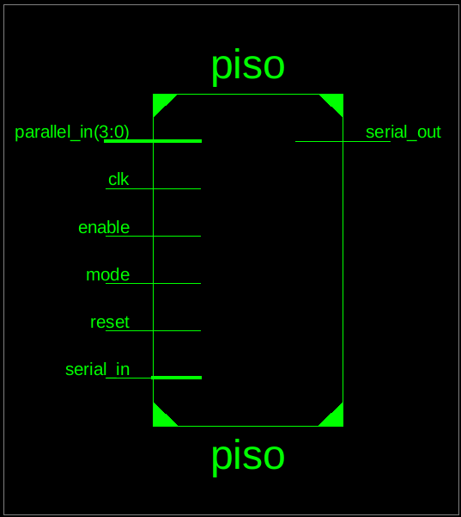 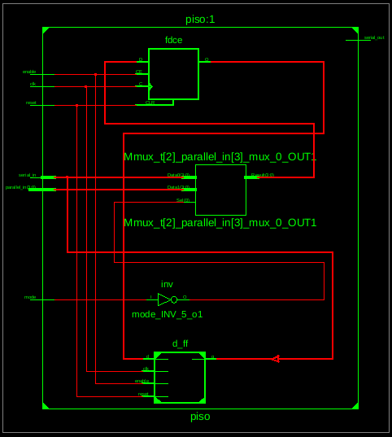

***● Testbench Code:   
--------------------------------------------------------------------------------***

***-- Company:***

***-- Engineer:***

***--***

***-- Create Date: 18:35:51 10/15/2024***

***-- Design Name:***

***-- Module Name: /home/ise/Assignment3/piso_tb.vhd***

***-- Project Name: Assignment3***

***-- Target Device:***

***-- Tool versions:***

***-- Description:***

***--***

***-- VHDL Test Bench Created by ISE for module: piso***

***--***

***-- Dependencies:***

***--***

***-- Revision:***

***-- Revision 0.01 - File Created***

***-- Additional Comments:***

***--***

***-- Notes:***

***-- This testbench has been automatically generated using types std_logic and***

***-- std_logic_vector for the ports of the unit under test. Xilinx recommends***

***-- that these types always be used for the top-level I/O of a design in order***

***-- to guarantee that the testbench will bind correctly to the post-implementation***

***-- simulation model.***

***--------------------------------------------------------------------------------***

***LIBRARY ieee;***

***USE ieee.std_logic_1164.ALL;***

***-- Uncomment the following library declaration if using***

***-- arithmetic functions with Signed or Unsigned values***

***--USE ieee.numeric_std.ALL;***

***ENTITY piso_tb IS***

***END piso_tb;***

***ARCHITECTURE behavior OF piso_tb IS***

***-- Component Declaration for the Unit Under Test (UUT)***

***COMPONENT piso***

***PORT(***

***clk : IN std_logic;***

***reset : IN std_logic;***

***enable : IN std_logic;***

***mode : IN std_logic;***

***parallel_in : IN std_logic_vector(3 downto 0);***

***serial_in : IN std_logic;***

***serial_out : OUT std_logic***

***);***

***END COMPONENT;***

***--Inputs***

***signal clk : std_logic := '0';***

***signal reset : std_logic := '0';***

***signal enable : std_logic := '0';***

***signal mode : std_logic := '0';***

***signal parallel_in : std_logic_vector(3 downto 0) := (others => '0');***

***signal serial_in : std_logic := '0';***

***--Outputs***

***signal serial_out : std_logic;***

***-- Clock period definitions***

***constant clk_period : time := 100 ns;***

***BEGIN***

***-- Instantiate the Unit Under Test (UUT)***

***uut: piso PORT MAP (***

***clk => clk,***

***reset => reset,***

***enable => enable,***

***mode => mode,***

***parallel_in => parallel_in,***

***serial_in => serial_in,***

***serial_out => serial_out***

***);***

***-- Clock process definitions***

***clk_process :process***

***begin***

***clk <= '0';***

***wait for clk_period/2;***

***clk <= '1';***

***wait for clk_period/2;***

***end process;***

***-- Stimulus process***

***stim_proc: process***

***begin***

***reset <= '1';***

***wait for 100 ns;***

***reset <= '0';***

***wait for 100 ns;***

***enable <= '1';***

***mode <= '0';***

***parallel_in <= "0101";***

***wait for 100 ns;***

***mode <= '1';***

***serial_in <= '1';***

***wait for 100 ns;***

***wait for 100 ns;***

***serial_in <= '0';***

***wait for 100 ns;***

***serial_in <= '1';***

***wait for 100 ns;***

***serial_in <= '1';***

***wait for 100 ns;***

***wait;***

***end process;***

***END;***

***● Waveform:***

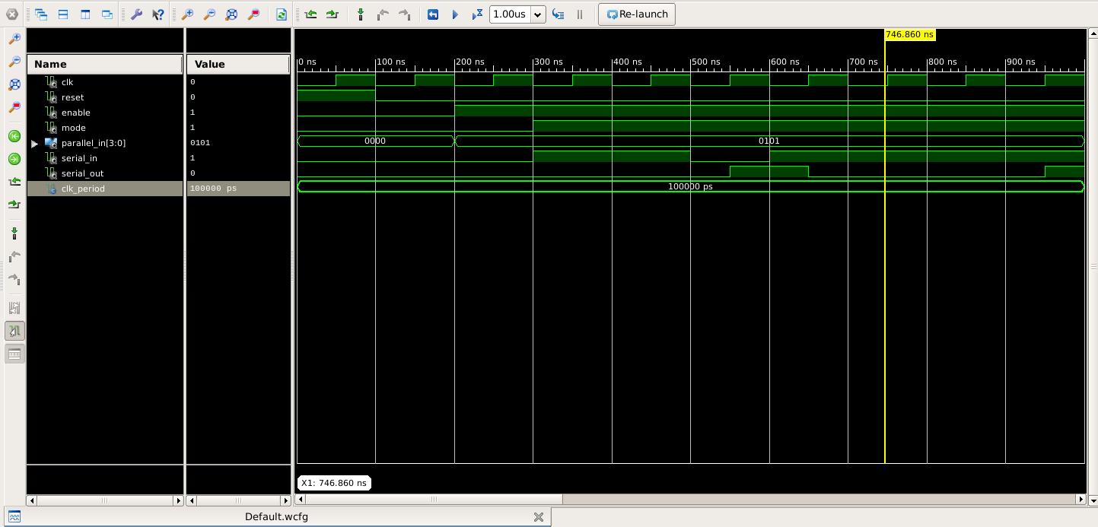

**Question 4**

**Develop a VHDL model to design a four bit ripple counter using D flip flop components. Use an enable and reset input pin to enable and reset the counter.**

**Aim : To develop a VHDL model for designing a 4-bit ripple counter using D flip-flop components. The design will include an enable input to control the counting operation and a reset input to asynchronously reset the counter to zero**

**Block Diagram :**

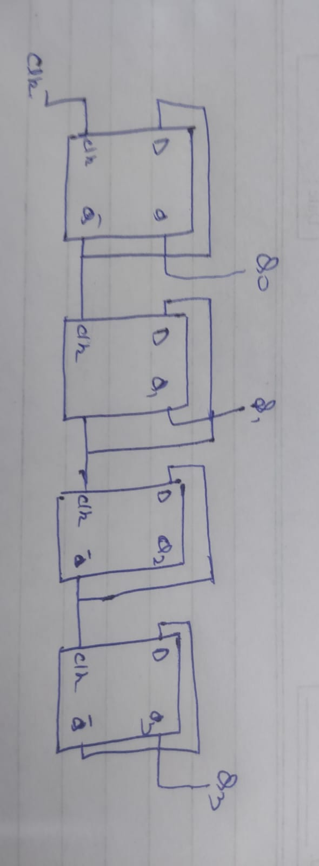

***● VHDL Code:***

***----------------------------------------------------------------------------------***

***----------------------------------------------------------------------------------***

***-- Company:***

***-- Engineer:***

***--***

***-- Create Date: 18:41:12 10/15/2024***

***-- Design Name:***

***-- Module Name: ripple_counter - Behavioral***

***-- Project Name:***

***-- Target Devices:***

***-- Tool versions:***

***-- Description:***

***--***

***-- Dependencies:***

***--***

***-- Revision:***

***-- Revision 0.01 - File Created***

***-- Additional Comments:***

***--***

***----------------------------------------------------------------------------------***

***library IEEE;***

***use IEEE.STD_LOGIC_1164.ALL;***

***-- Uncomment the following library declaration if using***

***-- arithmetic functions with Signed or Unsigned values***

***--use IEEE.NUMERIC_STD.ALL;***

***-- Uncomment the following library declaration if instantiating***

***-- any Xilinx primitives in this code.***

***--library UNISIM;***

***--use UNISIM.VComponents.all;***

***entity ripple_counter is***

***port(***

***clk : in STD_LOGIC;***

***enable : in STD_LOGIC;***

***reset : in STD_LOGIC;***

***count : out STD_LOGIC_VECTOR(3 downto 0)***

***);***

***end ripple_counter;***

***architecture Behavioral of ripple_counter is***

***component d_ff is***

***port ( d : in std_logic;***

***clk : in std_logic;***

***enable : in std_logic;***

***reset : in std_logic;***

***q : out std_logic);***

***end component;***

***signal t:std_logic_vector (3 downto 0); signal d_input : std_logic_vector(3 downto 0);***

***begin***

***d_input(0) <= not t(0);***

***d_input(1) <= not t(1);***

***d_input(2) <= not t(2);***

***d_input(3) <= not t(3);***

***step1:d_ff port map(d=>d_input(0),clk=>clk,enable=>enable,reset=>reset,q=>t(0));***

***step2:d_ff port map(d=>d_input(1),clk=>t(0),enable=>enable,reset=>reset,q=>t(1));***

***step3:d_ff port map(d=>d_input(2),clk=>t(1),enable=>enable,reset=>reset,q=>t(2));***

***step4:d_ff port map(d=>d_input(3),clk=>t(2),enable=>enable,reset=>reset,q=>t(3));***

***process(clk, reset)***

***begin***

***if reset = '1' then***

***count <= "0000";***

***elsif rising_edge(clk) then***

***if enable = '1' then***

***count <= t;***

***end if;***

***end if;***

***end process;***

***end Behavioral;***

***● RTL Diagram:***

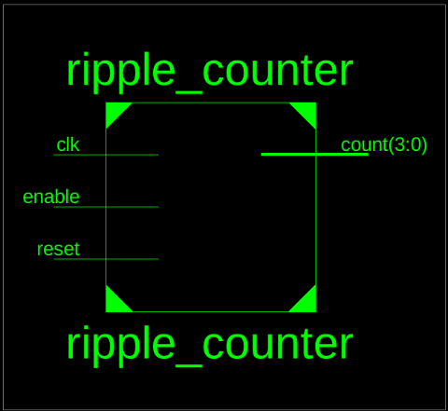 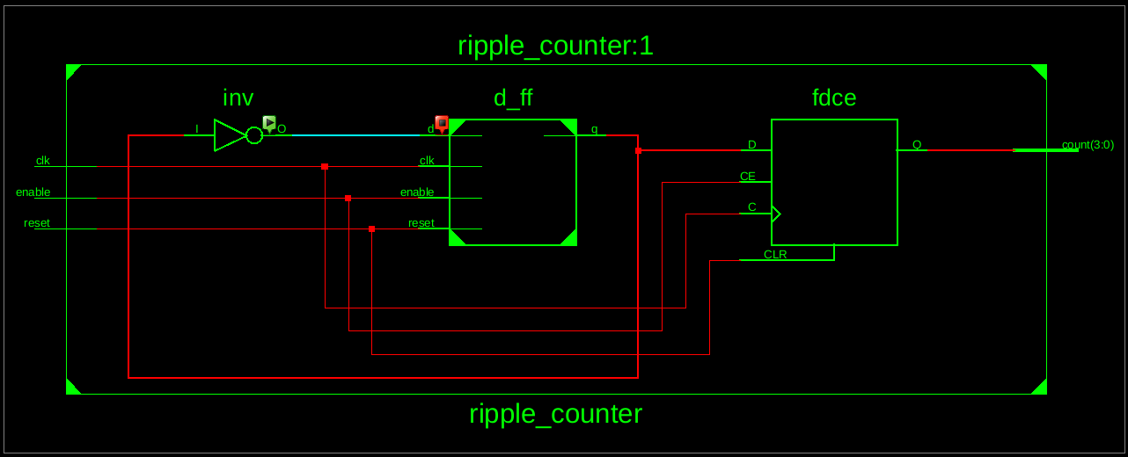

***● Testbench Code:   
--------------------------------------------------------------------------------***

***-- Company:***

***-- Engineer:***

***--***

***-- Create Date: 18:48:52 10/15/2024***

***-- Design Name:***

***-- Module Name: /home/ise/Assignment3/ripple_counter_tb.vhd***

***-- Project Name: Assignment3***

***-- Target Device:***

***-- Tool versions:***

***-- Description:***

***--***

***-- VHDL Test Bench Created by ISE for module: ripple_counter***

***--***

***-- Dependencies:***

***--***

***-- Revision:***

***-- Revision 0.01 - File Created***

***-- Additional Comments:***

***--***

***-- Notes:***

***-- This testbench has been automatically generated using types std_logic and***

***-- std_logic_vector for the ports of the unit under test. Xilinx recommends***

***-- that these types always be used for the top-level I/O of a design in order***

***-- to guarantee that the testbench will bind correctly to the post-implementation***

***-- simulation model.***

***--------------------------------------------------------------------------------***

***LIBRARY ieee;***

***USE ieee.std_logic_1164.ALL;***

***-- Uncomment the following library declaration if using***

***-- arithmetic functions with Signed or Unsigned values***

***--USE ieee.numeric_std.ALL;***

***ENTITY ripple_counter_tb IS***

***END ripple_counter_tb;***

***ARCHITECTURE behavior OF ripple_counter_tb IS***

***-- Component Declaration for the Unit Under Test (UUT)***

***COMPONENT ripple_counter***

***PORT(***

***clk : IN std_logic;***

***enable : IN std_logic;***

***reset : IN std_logic;***

***count : OUT std_logic_vector(3 downto 0)***

***);***

***END COMPONENT;***

***--Inputs***

***signal clk : std_logic := '0';***

***signal enable : std_logic := '0';***

***signal reset : std_logic := '0';***

***--Outputs***

***signal count : std_logic_vector(3 downto 0);***

***-- Clock period definitions***

***constant clk_period : time := 10 ns;***

***BEGIN***

***-- Instantiate the Unit Under Test (UUT)***

***uut: ripple_counter PORT MAP (***

***clk => clk,***

***enable => enable,***

***reset => reset,***

***count => count***

***);***

***-- Clock process definitions***

***clk_process :process***

***begin***

***while true loop***

***clk <= '0';***

***wait for clk_period/2;***

***clk <= '1';***

***wait for clk_period/2;***

***end loop;***

***end process;***

***-- Stimulus process***

***stim_proc: process***

***begin***

***reset <= '1';***

***enable <= '0';***

***wait for 20 ns;***

***reset <= '0';***

***wait for 20 ns;***

***enable <= '1';***

***wait for 50 ns;***

***enable <= '0';***

***wait for 20 ns;***

***enable <= '1';***

***wait for 50 ns;***

***reset <= '1';***

***wait for 20 ns;***

***reset <= '0';***

***wait for 20 ns;***

***enable <= '1';***

***wait for 50 ns;***

***wait;***

***end process;***

***END;***

***● Waveform:***

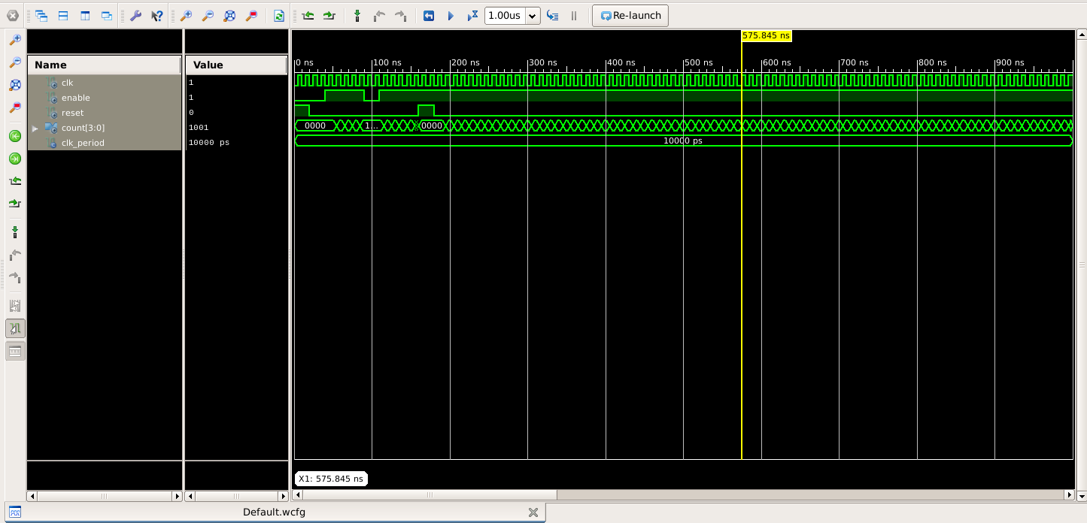

Proof That it Was Not Copied

***You can check My Github Account***

https://github.com/ij-roy/Semester-3/tree/main/COA/Assignment%203

***I had uploaded Every picture and code used above and you can also check the Date of Upload***

**Thank You**